Installation Instructions for

Hanging Tri-Flex Loop®

Thank you for ordering the Flex-Hose Co., Inc. hanger assembly kit for the installation of your TRI-FLEX LOOP. You will find the use of the kit to be time saving and easy to install. Please use the following instructions for installation:

IMPORTANT:

1. Use GOLD (formerly red) cable kit for installing all Tri-Flex Loops of up to 8” in diameter.

Contents of kit:

2 ea URC clips

8 ea Zinc plated copper oval sleeves (only 4 required -4 extra sleeves provided)

2 ea Gold cables, 13 feet long

You will also need one #0-12-SBHS crimping tool and one C7 FELCO cable cutter to install kit. (Tools are not provided in the kit, they are sold separately).

2. Use GREEN (formerly blue) cable kit for installing all Tri-Flex Loops of 10” and 12” in diameter.

Contents of kit:

2 ea URC clips

8 ea Zinc plated copper oval sleeves (only 4 required -4 extra sleeves provided)

2 ea Green cables, 13 feet long

3. Use Green 2 cable kit for installing all Tri-Flex Loops over 12” in diameter.

Contents of kit:

4 each URC clips (2 required if weld or bolt to structure, 4 if to decking)

12 each Zinc plated copper oval sleeve (only 8 required -4 extra sleeves provided)

4 each Green Cables, 13 feet long

You will also need one #3-346SB crimping tool and one C9 FELCO cable cutter to install kit. (Tools are not provided in the kit, they are sold separately).

INSTALLATION:

1. First install overhead attachment for TRI-FLEX Loop. (See “Elevation” diagram on page 2 for illustration). Install ITW Trubolt concrete anchor, size ½”X 5 ½’ (not provided). Concrete anchor must have a minimum embedment depth of 4 - 1/8”.

2. Secure URC clip with ½” hole over anchor stud using nut and washer. The two “ears” of the URC clip should face downward.

3. Slide one zinc plated copper oval sleeve onto one loose end of the cable. Thread cable through hole in one of the “ears” of the URC clip. (Either ear is ok, but thread through only one ear on sizes 12” diameter and smaller. For sizes over 12” diameter you will put a cable though both ears). Form a loop in the cable and slide cable end back through the zinc plated copper oval sleeve. Make sure cable end extends entirely through the end of the zinc plated copper oval sleeve (as shown in “Elevation” on page 2).

4. Crimp zinc plated copper oval sleeve.

**Hanger Assembly Kit for Tri-Flex Loop®**



**Break Strength Certified ♦ Color Coded ♦ Pre-stretched**

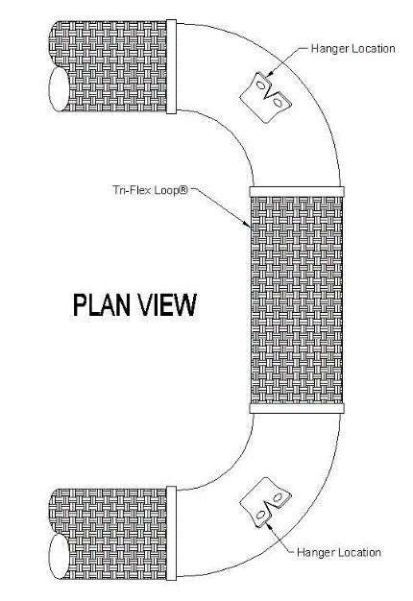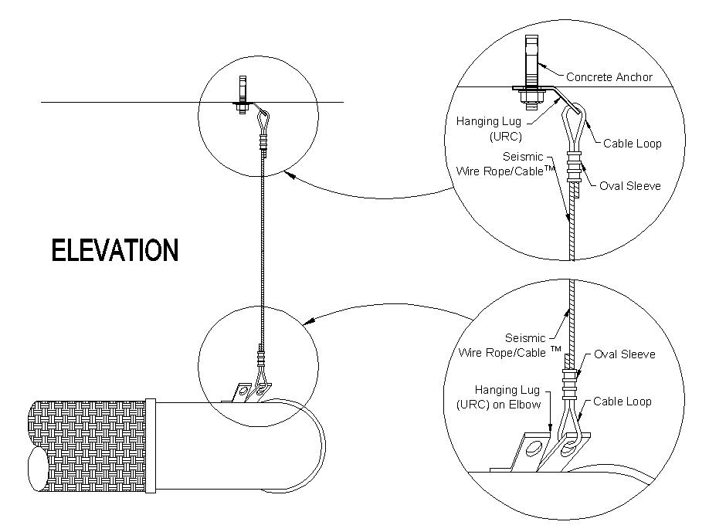

|  |  |  |  |  |  |
| --- | --- | --- | --- | --- | --- |
| **Tri-Flex Loop**  **Size** | **Anchor**  **Size** | **Anchor**  **Embedment** | **URC**  **Size** | **Cable, Oval Sleeve,**  **Thimble Size** | **Number**  **of Crimps** |
| 8" & Smaller | ½" x 5½" | 4½” | ½” | 12 (GOLD) | 2 * |
| 10" & 12" | ½" x 5½" | 4½" | ½” | 36 (GREEN) | 3 ** |
| ***14” & UP | 5/8” x 5½" | 4¾” | 5/8” | 36 (GREEN) | 3 ** |

*Use Locoloc® #1-SBHS Hand Swager or #3-346SB Hand Swager.

** Use Locoloc ® #3-346SB Hand Swager.

*** For 14” diameter and larger; if anchoring in concrete deck use one URC on deck with anchors spaced 12 bolt diameters apart for each of the four cables.  Each URC on the Tri-Flex Loop will have two cables and each one of the cables will go to individual URC’s on the deck to distribute the load.

FOR GOLD CABLE:

Use tool #0-12- SBHS (ratchet style). Crimp zinc plated copper oval sleeve two times. Follow crimping instructions provided with tool. Use 3/32” cavity for crimping zinc plated copper oval sleeves on gold cable.

FOR GREEN CABLE:

Use tool #3-346SB (large size tool). Crimp zinc plated copper oval sleeve three times. Follow crimping instructions provided with tool. Use 3/16” cavity (marked green) for crimping zinc plated copper oval sleeves on green cable.

5. Cut off excess cable using FELCO cable cutter.

6. Install other end of cable to TRI-FLEX LOOP as shown in Figure “Elevation” on page 2. Use same methods of installing cable and crimping zinc plated oval sleeves as described above.

**SPECIAL NOTE: On 14” diameter and larger there will be two cables on each URC clip.**

7. Use crimping/swaging gauge provided with the crimp/swage tool to check proper crimp/swage diameter. Compressed sleeves should slide freely into appropriate size slot of the gage.

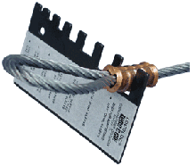

**Inspection & Maintenance**

1. The cable hanger assembly should be inspected during routine maintenance to ensure there are no signs of external damage. Inspect for frayed or broken cable wires. Use a glove protected hand, or cloth, and gently slide along the length of the cable. If there are pulled or damaged wires, they will snag on the glove or cloth. The cables should be replaced if any damaged or broken cable wires are detected.
2. Every application and environment is unique. Visually inspect the attachment points at each end of the cable. Look for evidence of rust and/or other corrosion on the cables, URC clips (or other mount attachments) and crimp sleeves. If corrosion is found the corroded components should be replaced.
3. In the event of seismic activity, the hangers (and the components they are supporting) should be inspected to insure they have not suffered damage from movement, or load, beyond their rated capability. If it is suspected that overloading and/or movement has occurred, the hanger assembly should be replaced.
4. To obtain the best possible performance from the crimp/swage tool follow the instructions provided with the tool. We recommend:

(1) Clean and lubricate all moving parts regularly

(2) Keep all bolts tight

(3) Keep the crimp/swage tool properly adjusted per the manufacturer’s instructions